Jacob Snyder

AN127

HW3

1. Research question: Is stock market performance dependent on a country’s corruption?
2. Models: linear regression
3. Size of Stock Market
$Stock Market Size=β_{0}+β_{1}WGI+β_{2}Precipitation+β_{3}GINI_index+β_{4}GDP+ϵ$

4. Volatility of Stock market
$Stock Market Volatility=β_{0}+β_{1}WGI+β_{2}Precipitation+β_{3}GINI_index+β_{4}GDP+ϵ$

5. Excel table attached separately
6. Operationalization of variables

* Control of Corruption
  + Compiled from multiple variables and sources by the World Bank. Details about this aggregation can be found in a detailed format at <http://info.worldbank.org/governance/wgi/Home/downLoadFile?fileName=cc.pdf>
  + We are using 2011 data.
  + Source: <http://info.worldbank.org/governance/wgi/>
* Stocks Traded
  + Total value of stocks traded over the course of a year, as a % of GDP. Figures are single counted (only one side of the transaction is considered). Gathered from the World Federation of Exchanges database.
  + We are using 2011 data.
  + Source: <https://data.worldbank.org/indicator/CM.MKT.TRAD.GD.ZS>
* Stock Volatility
  + 360-day standard deviation of the return on the national stock market index. Gathered by the Federal Reserve Economic Data from the World Bank.
  + Source: <https://fredaccount.stlouisfed.org/public/datalist/1601>
* GDP/capita
  + Gross Domestic Product (over 1 year) divided by midyear population. Measured in US dollars.
  + Source: <https://data.worldbank.org/indicator/NY.GDP.PCAP.CD>
* Precipitation
  + Year-long average of depth of precipitation (in mm) in the country. Precipitation is defined as any kind of water that falls from clouds as a liquid or solid. The data is collected by the Food and Agriculture Organization of the United Nations (FAO) using annual questionnaires. The FAO tries to impose standard definitions and reporting methods, but complete consistency across countries and over time is not possible.
  + We are using 2012 data.
  + Source: <https://data.worldbank.org/indicator/AG.LND.PRCP.MM>
* Ease of Doing Business
  + RANKING of economies from 1 to 190, where 1 is the easiest to do business with and 190 is the most difficult. The ranking is formed according to the **Doing Business** World Bank project, providing objective measures of business regulations and their enforcement across 190 economies. More info about this project can be found here: <https://doingbusiness.org>
  + Using 2019 data (only year where data is available)
  + Source: <https://data.worldbank.org/indicator/IC.BUS.EASE.XQ>
* GINI index
  + GINI index measures the extent to which the distribution of income within an economy deviates from a perfectly equal distribution. Data is collected by the **Poverty and Inequality Platform** of the World Bank. The data is collected using household survey data and the Luxembourg Income Study database.
  + We are prioritizing 2011 data. If 2011 data is missing, we use 2012. If 2012 is missing, we use 2013. If 2013 is missing, we use 2014.
  + Source: <https://data.worldbank.org/indicator/SI.POV.GINI>

1. Reference List

# Bibliography

Avnimelech, Gil. "The effect of corruption on entrepreneurship in developed vs non-developed countries." 2014.

Ayaydin, Hasan. "Corruption, banking sector, and stock market development: A panel data analysis." 2013.

Bardhan, Pranab. "Corruption and Development: A Review of Issues." 1997.

Bolgorian, Meysam. *Corruption and stock market development: A quantitative approach*. Tehran: University of Tehran, 2011.

Dudley, Richard G. "The Rotten Mango: The Effect of Corruption on International Development Projects." 2000.

Evrensel, Ayse Y. "Corruption, growth, and growth volatility." 2010.

Krishnamurti, Chandrasekhar. "Corruption risk and stock market effects: Evidence from the defence industry." 2021.

Mouselli, Sulaiman. "CORRUPTION AND STOCK MARKET DEVELOPMENT: NEW EVIDENCE FROM GCC COUNTRIES." 2016.

Ng, David. "The impact of corruption on financial markets." 2006.

Omodero, Cordelia Onyinyechi. "Corruption And Stock Market Performance In Nigeria." 2018.

Pinheiro, Ana Raquel Da Costa. "Does corruption drive the stock market." 2010.

Spyromitros, Eleftherios. "The effect of corruption on stock market volatility." 2020.

Zhang, Aimao. "An Examination of the Effects of Corruption on Financial Market Volatility." 2013.

1. Statistical Methods

* Standard linear regression. Use of correlation table to avoid multicollinearity. May use variable transformations to ensure linear relationships. May use robustness checks.

1. Correlation table:

1. Regression results:

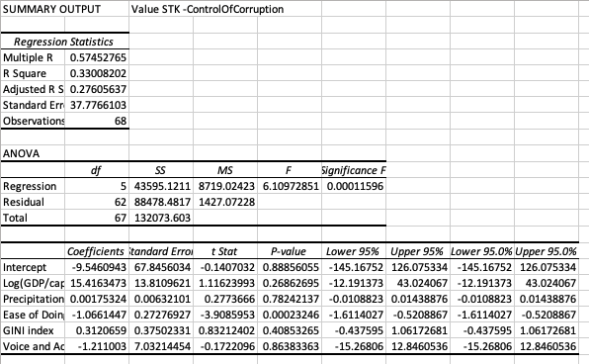

1. Notable Bivariate Plot:

